Chapter 19, Solution 35.

To get 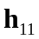 and 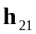 consider the circuit in Fig. (a).
4 
1 
I₁
(a)
I₂
+
V₂ = 0
−
+
V₁
−
1 : 2
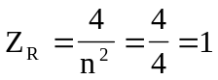

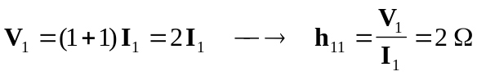

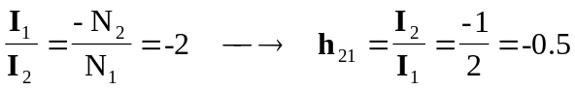

To get 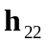 and 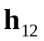, refer to Fig. (b).
4 
1 
(b)
I₂
+
V₁
−
1 : 2
I₁ = 0
V₂
−
+

Since 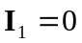, 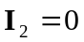.
Hence, 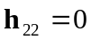.

At the terminals of the transformer, we have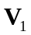 and 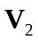 which are related as
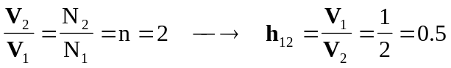

Thus,
